National College of Computer Studies
Paknajol, Kathmandu



Report on
Fish and Accessories Store

Submitted by: Submitted to:
Hrikesh Aran Yachu Shakya

BSc.CSIT 5th Sem
Section: A
Submission Date: April 30, 2026
Contents

Abstract i
1. Introduction 1
2. Problem Statement 2
3. Objectives 3
4. Diagrams 4
5. Screenshots of the Application 8
6. Conclusion 13
7. Future Implementation 14

Abstract
The Fish & Accessories Store System is a web-based e-commerce platform designed to facilitate the online buying and selling of fish, aquariums, and related accessories. The system enables users to browse products, register accounts, place orders, and manage their purchases through an interactive interface. Administrators can manage product listings, monitor orders, and maintain the system via a dedicated dashboard.

Developed using HTML, CSS, JavaScript, and PHP with MySQL as the backend database, the system replaces traditional in-store purchasing with a digital platform. This improves accessibility, enhances user experience, and streamlines store management. The system is modular and can be extended with additional features such as online payments and delivery tracking.

1. Introduction
The Fish & Accessories Store System is designed to modernize the process of purchasing aquarium products by providing a centralized online platform. Traditionally, customers must visit physical stores to explore fish varieties and accessories, which can be time-consuming and limiting in terms of choice.

This system allows users to browse a wide range of products, view detailed descriptions, and make purchases online. It also includes user authentication, enabling customers to manage their accounts and orders securely. The admin dashboard allows store owners to add, update, and delete products, ensuring efficient inventory management.

Built using PHP for backend processing and MySQL for data storage, the system demonstrates a complete client-server architecture. It integrates frontend technologies for a responsive user interface and backend logic for handling business operations.

2. Problem Statement
Traditional fish and aquarium accessory stores rely heavily on physical presence and manual processes for sales and inventory management. Customers have limited access to product information and must visit stores to explore available items.

Store owners face challenges such as:

- Managing inventory manually
- Limited reach to customers
- Difficulty tracking orders and sales
- Lack of digital record-keeping

Customers, on the other hand:

- Cannot easily compare products
- Have no access to online purchasing
- Face inconvenience in visiting stores

A web-based system is needed to provide a seamless shopping experience and improve operational efficiency.

3. Objectives

The main objective of the Fish & Accessories Store System is to provide a user-friendly online platform for buying fish and related products.

Specific Objectives include:
- Allow users to browse fish and accessories with detailed descriptions.
- Enable user registration and secure login.
- Provide an online ordering and checkout system.
- Develop an admin dashboard for product management.
- Store and manage data using a MySQL database
- Ensure responsive design for different devices
- Improve customer experience through an intuitive interface

4. Diagrams
Use Case Diagram
The use case diagram illustrates the interactions between three primary actors and the system: the Guest, the Registered User, and the Administrator. The Guest can search products, browse products, and view product details without logging in. However, to access advanced features such as adding items to the cart, placing orders, and viewing order history, the user must register and log in as a Registered User.
The Registered User can register an account, log in, search and browse products, view detailed product information, add items to the cart, proceed to checkout, place orders, and view their order history. The system ensures that only authenticated users can perform purchase-related actions.
The Administrator can log in to the admin panel and manage the overall system. This includes viewing the admin dashboard, managing users, managing products (adding, editing, and deleting items), managing orders, and viewing site statistics. The admin has full control over the system to maintain and update the platform efficiently.
Both the Registered User and the Administrator share the login functionality. The ‘Checkout / Place Order’ use case includes ‘Add to Cart’ as a prerequisite (include relationship), and ‘Reset Password’ extends the ‘Login’ use case (extend relationship). The ‘View Admin Dashboard’ use case includes management functionalities such as managing users, products, and orders, and these features are restricted to the Administrator role.

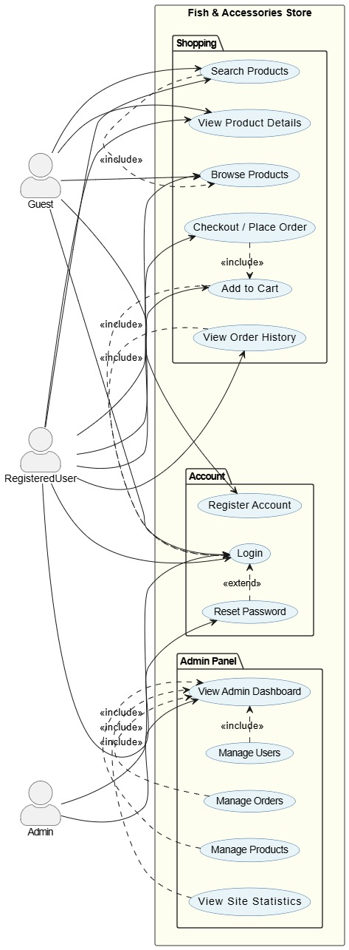
Fig: Use Case Diagram of Fish and Accessories Store

ER Diagram
The Entity-Relationship diagram shows four primary entities and their relationships:
- USER (user_id, username, email, password, phone, address, role, created_at) – stores information about all users of the system, including both customers and administrators, distinguished by the role attribute.
- PRODUCT (product_id, name, price, categories, size, species, description) – represents each product available in the store, including fish and accessories, along with their details.
- ORDER (order_id, user_id, full_name, email, phone, address, payment_method, status) – records each order placed by users, including customer details and order status.
- ORDER_ITEMS (orderitems_id, order_id, product_id, product_name, product_categories, quantity, price) – stores the details of products included in each order.
Relationships:
- A USER can place many ORDERS (one-to-many).
- An ORDER can contain multiple ORDER_ITEMS (one-to-many).
- Each ORDER_ITEM is associated with exactly one PRODUCT, while a PRODUCT can appear in many ORDER_ITEMS (one-to-many).
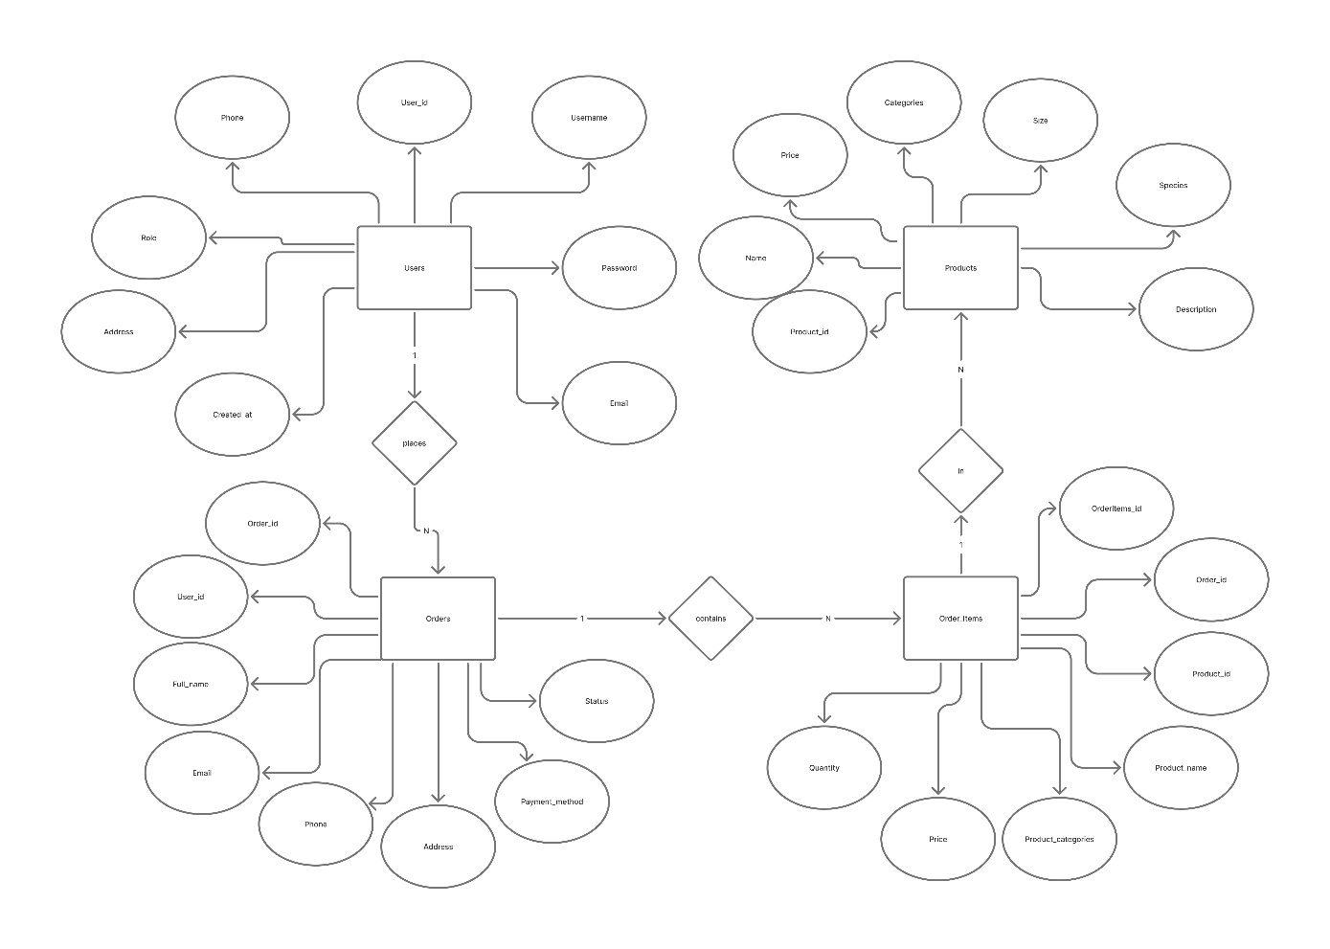

Fig: ER Diagram of Fish and Accessories Store System

5. Screenshots of the Application
This section presents key screens of the Fish and Accessories store application, demonstrating the user and administrator interfaces.
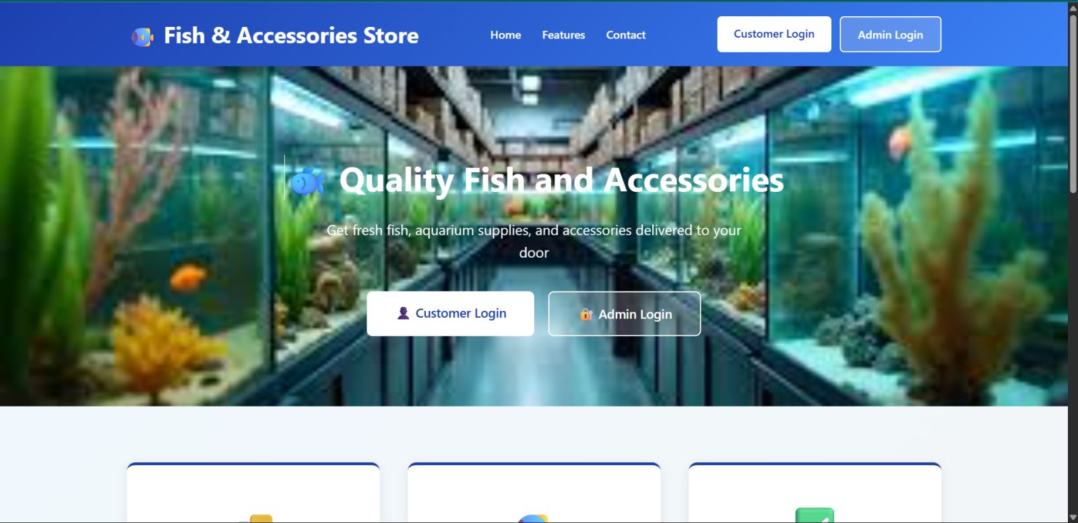
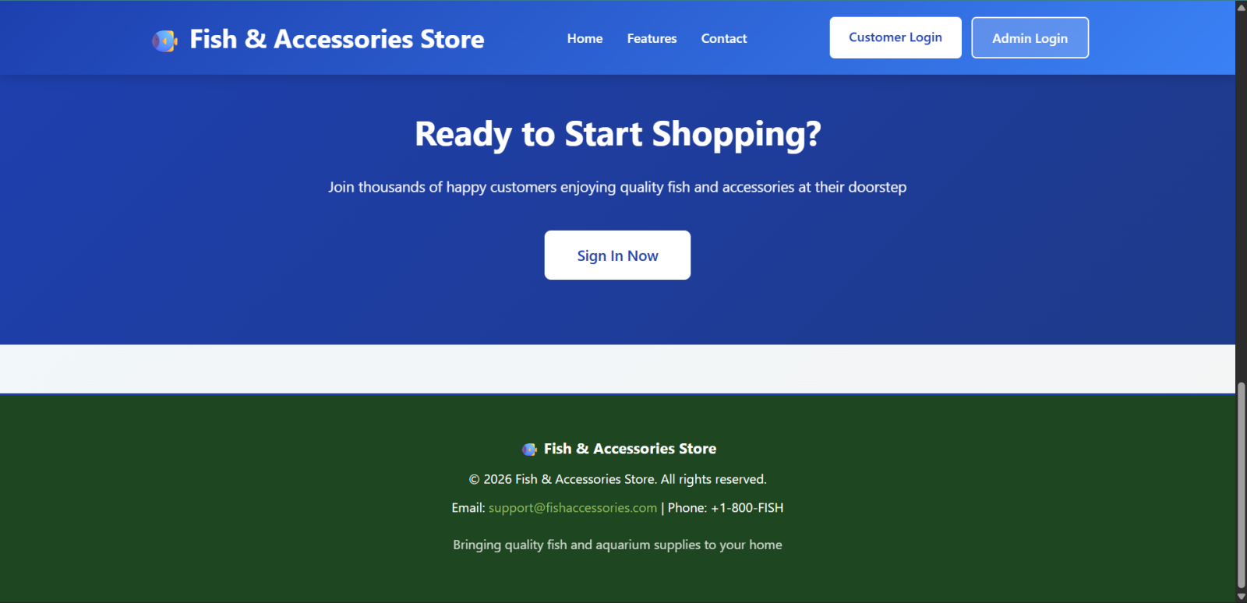

Fig 5.1: Home Page

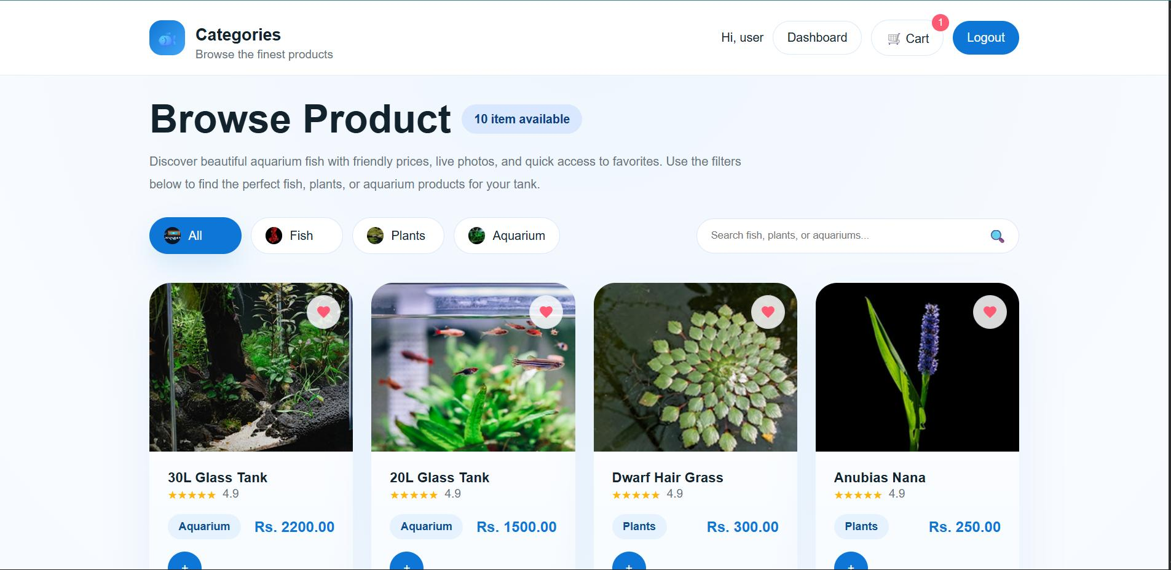
Fig 5.2: Product Listing Page

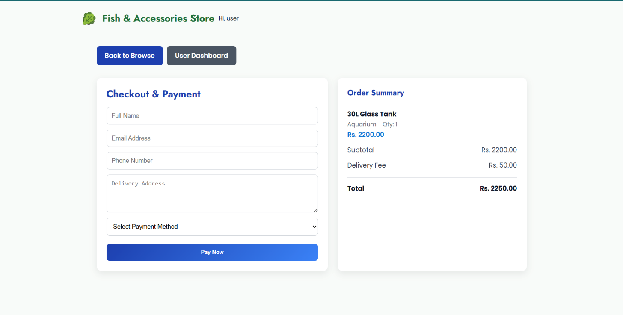
Fig 5.3: Checkout Page

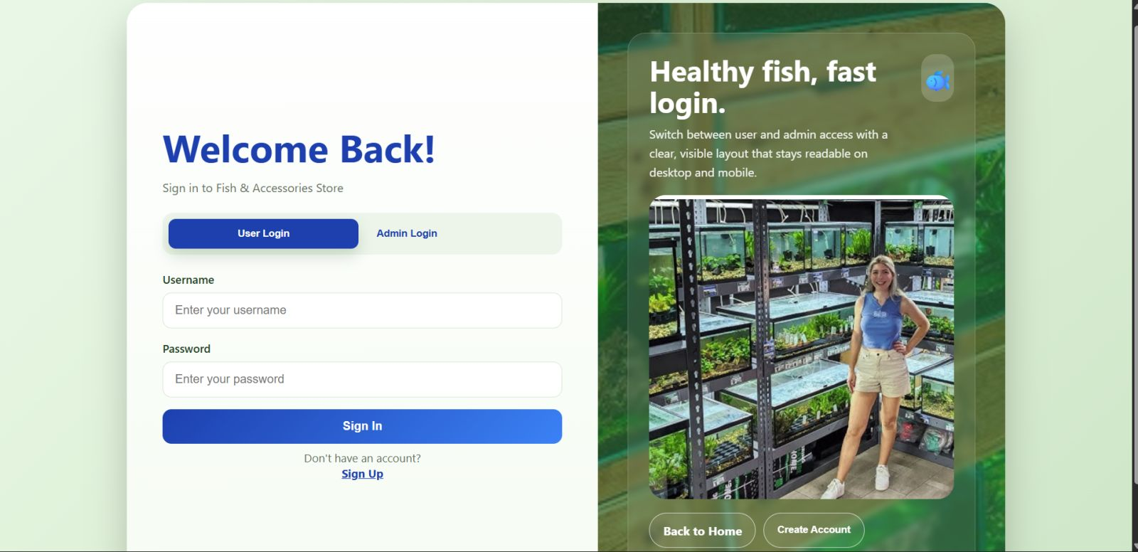
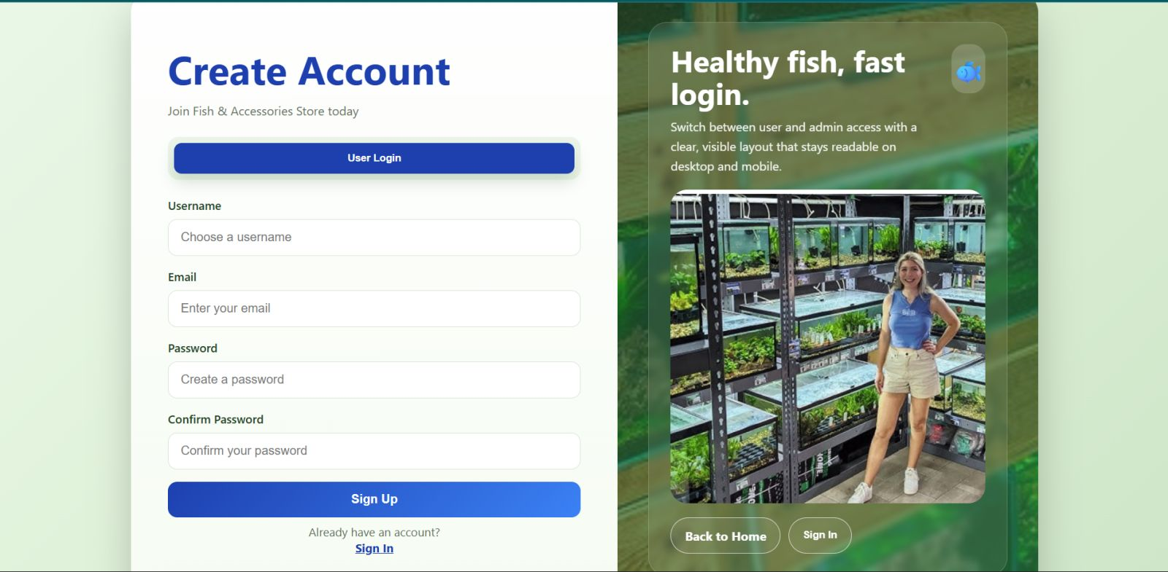
Fig 5.4: Login and Sign Up Pages

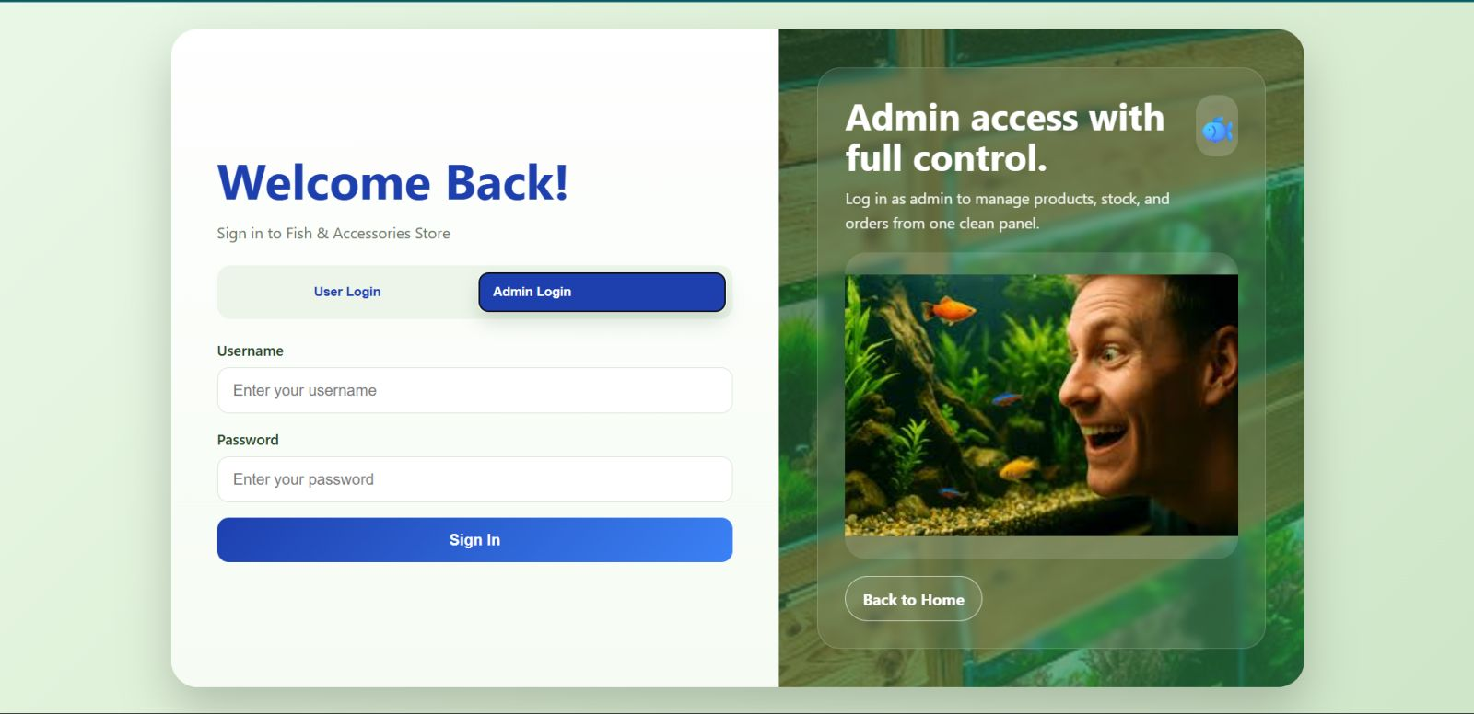
Fig 5.5: Admin Login Pages

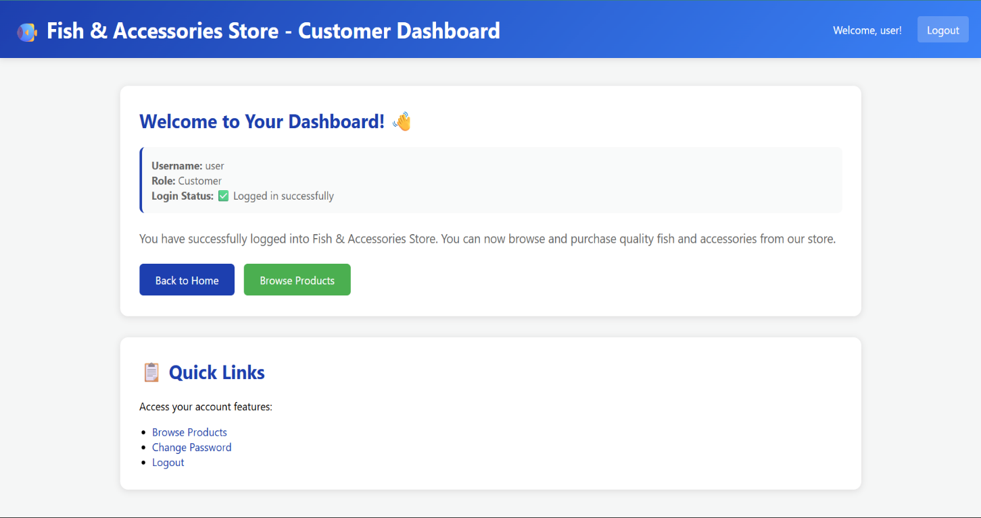
Fig 5.6: User Dashboard

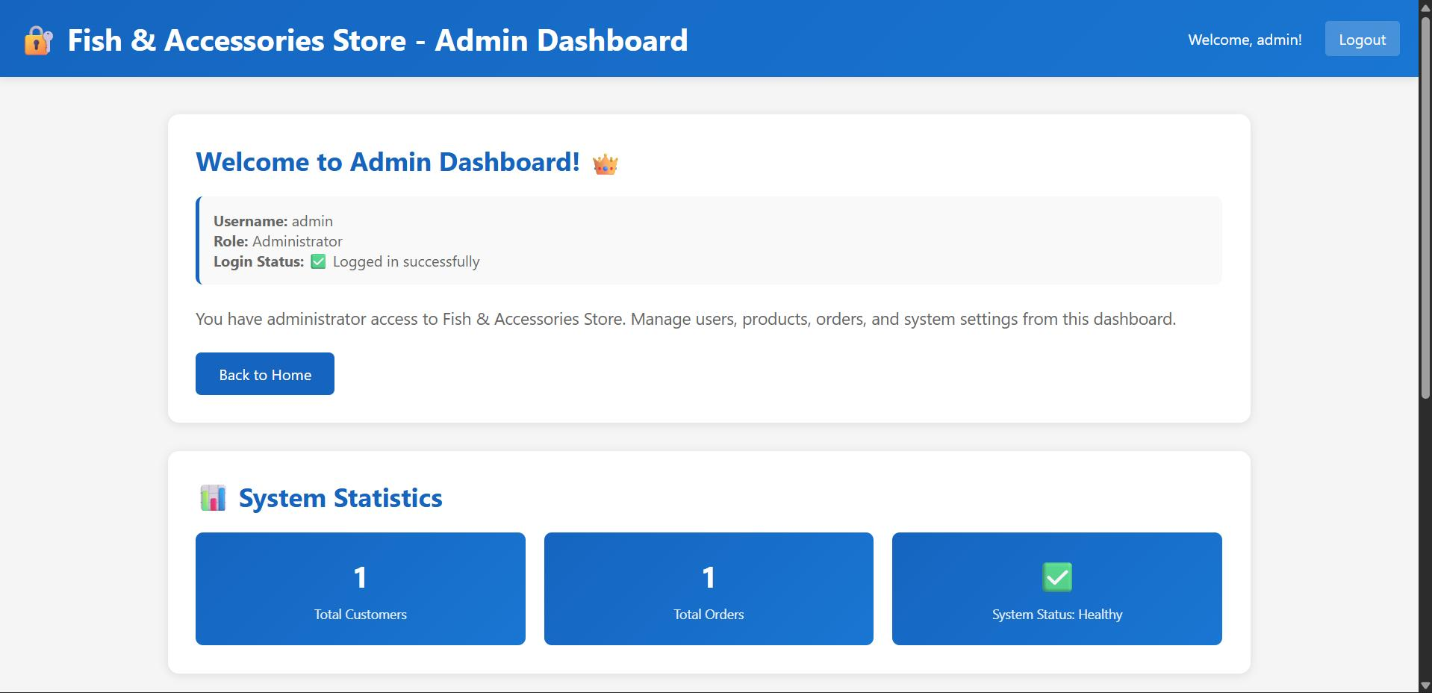
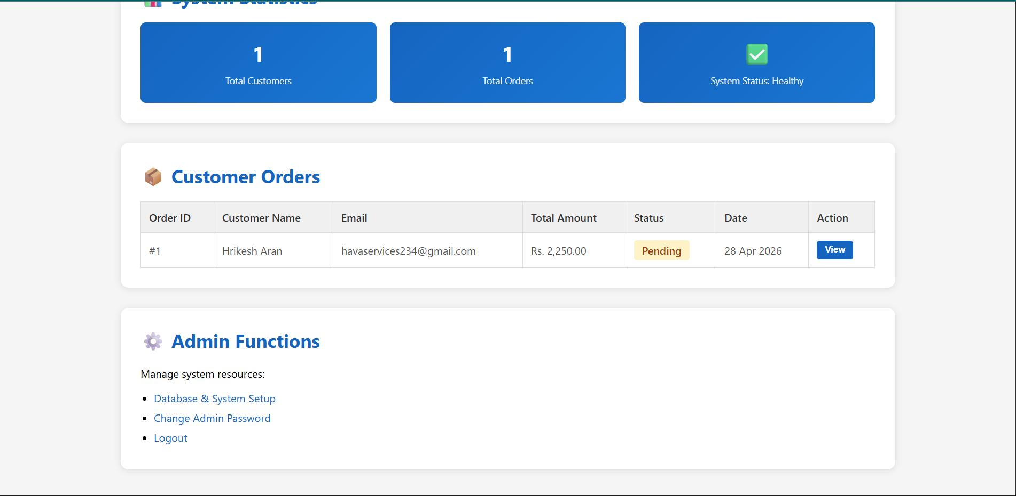
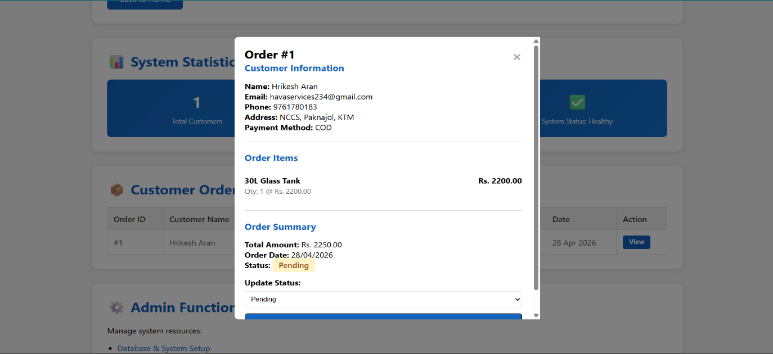
Fig 5.7: Admin Dashboard with Stats and Order Reviews and Manage section

6. Conclusion
The Fish & Accessories Store System successfully provides a digital solution for managing and purchasing aquarium products. It simplifies the shopping process for customers and enhances store management for administrators.

The system demonstrates key web development concepts, including database integration, session management, and dynamic content rendering. Its modular structure allows for easy maintenance and scalability.

Overall, the project serves as a practical implementation of an e-commerce platform and can be further developed into a full-scale commercial application.

7. Future Implementation
Proposed future enhancements for the Fish and Accessories Store system include:
- Integration with online payment systems (eSewa, Khalti, cards)
- Real-time order tracking
- Customer reviews and ratings
- Advanced search and filtering
- Mobile application development
- Email/SMS notifications
- Improved security (password hashing, validation)
- Inventory management system
- AI-based product recommendations

